# Project Design Phase-I Solution Architecture

|  |  |
| --- | --- |
| Date | 19 September 2022 |
| Team ID | PNT2022TMID22747 |
| Project Name | Project - Visualizing and Predicting Heart Diseases with an Interactive Dash Board |
| Maximum Marks | 4 Marks |

**Solution Architecture:**

The Software Architecture is followed by the following steps:

* The patient first registers by providing certain parameters.
* That registered data is collected in a database using machine learning techniques similar to data collection techniques, and when he goes to check on his health, the collected values or data that has been stored in the database is extracted.
* Classification is done using some feature extraction methods when data is extracted, it goes through certain processes, and as a result, a disease is created.
* The predicted data and a report is produced.

This is an overview of the machine-learning-based heart disease prediction system.

# Solution Architecture Diagram:

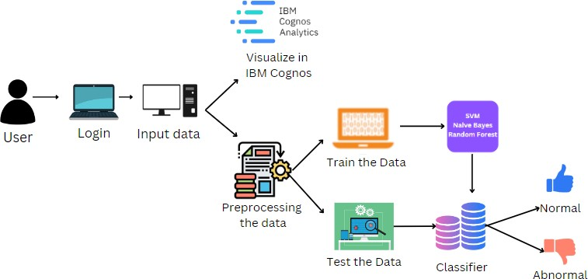

*Figure 1: Architecture and data flow of Visualizing and Predicting Heart Diseases with an Interactive Dash Board*